**Practical 7**

**To operate IR sensor with Raspberry pi.**

**Components Required :**

Raspberry Pi 3 (any model) , IR sensor Module , Green and Red LED lights , Breadboard and Connecting wires.

**\*IR Sensor :** IR (Infrared) Sensor works by emitting infrared signal/radiation and receiving of the signal when the signal bounces back from any obstacle. In other words, the IR Sensor works by continuously sending signal (in a direction) and continuously receive signal, if comes back by bouncing on any obstacle in the way.(Fig.7.1)

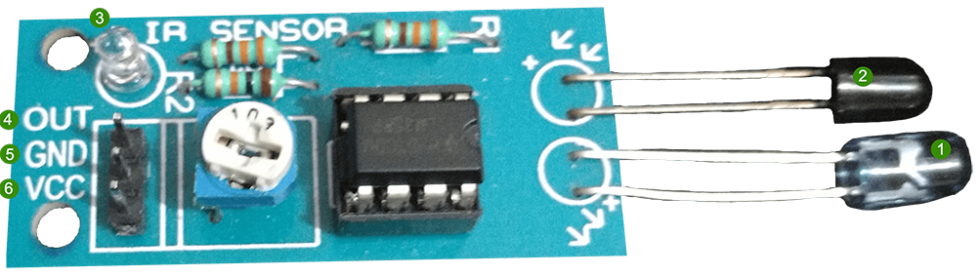

*Fig.7.1 IR Sensor*

**Circuit Diagram:**

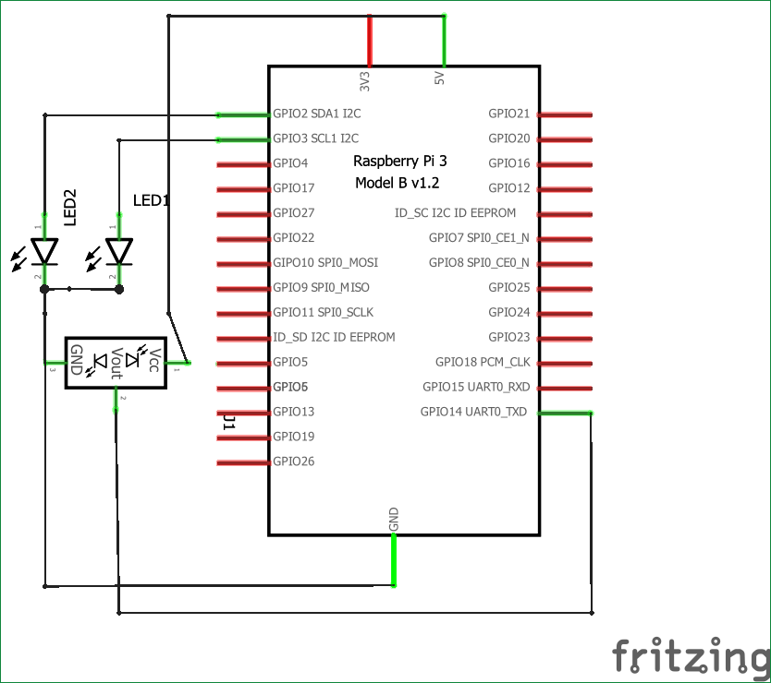

*Fig.7.2 IR sensor-Raspberry pi Connection*

**Python Code:**

import RPi.GPIO as IO  
import time  
IO.setwarnings(False)  
IO.setmode(IO.BCM)

IO.setup(2,IO.OUT) #GPIO 2 -> Red LED as output  
IO.setup(3,IO.OUT) #GPIO 3 -> Green LED as output  
IO.setup(14,IO.IN) #GPIO 14 -> IR sensor as input

while 1:

    if(IO.input(14)==True): #object is far away  
        IO.output(2,True) #Red led ON  
        IO.output(3,False) # Green led OFF  
      
    if(IO.input(14)==False): #object is near  
        IO.output(3,True) #Green led ON  
        IO.output(2,False) # Red led OFF

**Output:**

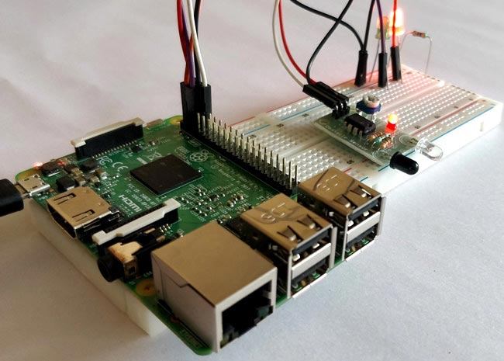

*Fig.7.3 Output*